**EdTech User Acquisition Analysis Project:**

This is a data analyst project in which I had extracted and analysed data and took out useful inferences from the given dataset. These inferences helped business teams to analyse the team performance and managers can focus on more specific target areas which will lead to increase in overall conversion rates.

**Data Reading and Cleaning:**

Create a database Edtech in Mysql and import all the given tables in that dataset:

create database edtech;

use edtech;

**Outliers:**

select * from lead_basic_details where age not between 10 and 50;

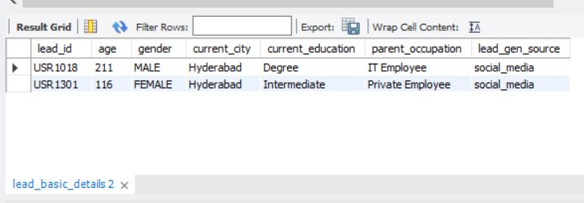

**INFERENCE – Two outliers are found with wrong age out of total 360 leads.**

**Total Leads:**

select count(distinct lead_id) from lead_basic_details;

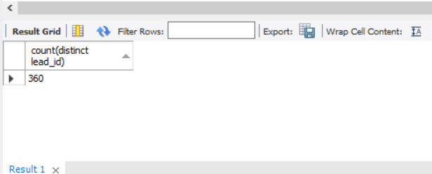

**Conversion rates of leads by current education:**

select a.current_education,count(distinct a.lead_id) as leads,

count(distinct case when b.lead_stage='conversion' then b.lead_id end) as converted_leads,

round(count(distinct case when b.lead_stage='conversion' then b.lead_id end)*100.00/count(distinct a.lead_id),2) as conversion_rates

from lead_basic_details a

join leads_interaction_details b

on a.lead_id=b.lead_id

group by 1;

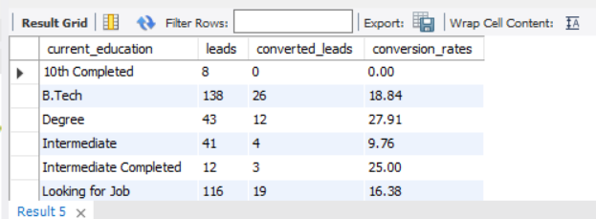

**INFERENCE-Conversion rates in Btech,Intermediate,10th completed is low we had to focus in these sections in correlation with other data to improve.**

**Conversion rates city wise:**

select a.current_city,count(distinct a.lead_id) as leads,

count(distinct case when b.lead_stage='conversion' then b.lead_id end) as converted_leads,

round(count(distinct case when b.lead_stage='conversion' then b.lead_id end)*100.00/count(distinct a.lead_id),2) as conversion_rates

from lead_basic_details a

join leads_interaction_details b

on a.lead_id=b.lead_id

group by 1;

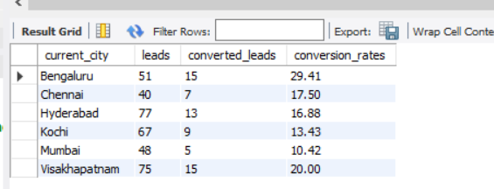

**INFERENCE-conversion rates of cities like kochi and mumbai is low we should focus on these cities more to improve conversion rate by corelating with other analysis.**

**Language Wise conversion Rates:**

select a.language,count(distinct a.lead_id) as leads,

count(distinct case when b.lead_stage='conversion' then b.lead_id end) as converted_leads,

round(count(distinct case when b.lead_stage='conversion' then b.lead_id end)*100.00/count(distinct a.lead_id),2) as conversion_rates

from leads_demo_watched_details a

join leads_interaction_details b

on a.lead_id=b.lead_id

group by 1;

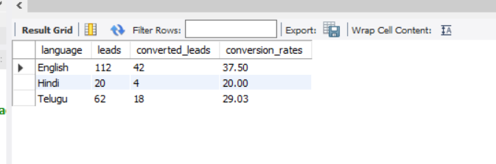

**INFERENCE-Conversion rate in Hindi is less so we hed to make more quality courses of Hindi.**

**Cycle wise convertion rates:**

select a.cycle,count(distinct a.lead_id) as leads,

count(distinct case when b.lead_stage='conversion' then b.lead_id end) as converted_leads,

round(count(distinct case when b.lead_stage='conversion' then b.lead_id end)*100.00/count(distinct a.lead_id),2) as conversion_rates

from sales_manager_assigned_leads_details a

join leads_interaction_details b

on a.lead_id=b.lead_id

group by 1;

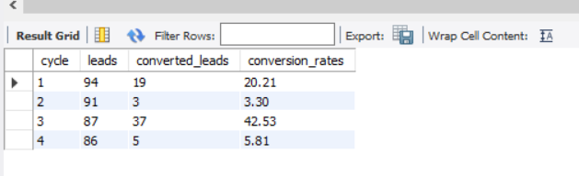

**INFERENCE- conversion rates of cycle 3 and 4 are extremely low so managers should focus more on team performance at that cycle time.**

**Conversion rates from every lead generation source:**

with base as (SELECT a.*,b.lead_gen_source

FROM edtech.leads_interaction_details a

left join lead_basic_details b on a.lead_id=b.lead_id)

Select lead_gen_source,count(distinct lead_id) as leads,

count(distinct case when lead_stage='conversion' then lead_id end) as converted_leads,

round(count(distinct case when lead_stage='conversion' then lead_id end)*100/count(distinct lead_id),2) as conversion_rate

from base

group by 1;

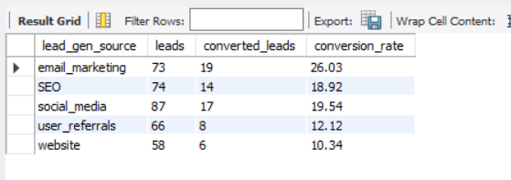

**INFERENCE-Conversion rates of user_referrals and website are low so business team should focus on these lead gen source to bring more quality leads and side by side also correlate with other analysis.**

**Lead stage Journey-Dropout rates at every lead stage:**

select jnr_sm_id,count(distinct lead_id) as total_leads, count(distinct case when lead_stage='lead' then lead_id end) as leads,

count(distinct case when lead_stage='awareness' then lead_id end) as awared_leads,

count(distinct case when lead_stage='consideration' then lead_id end) as considered_lead_stage,

count(distinct case when lead_stage='conversion' then lead_id end) as converted_leads

from leads_interaction_details

group by 1;

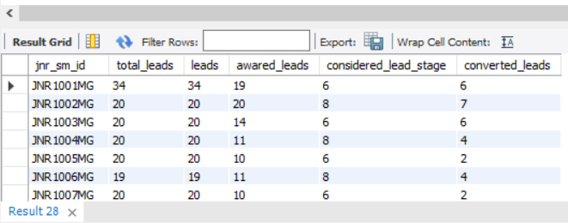

with base as(select jnr_sm_id,count(distinct lead_id) as total_leads, count(distinct case when lead_stage='lead' then lead_id end) as leads,

count(distinct case when lead_stage='awareness' then lead_id end) as awared_leads,

count(distinct case when lead_stage='consideration' then lead_id end) as considered_lead_stage,

count(distinct case when lead_stage='conversion' then lead_id end) as converted_leads

from leads_interaction_details

group by 1)

select jnr_sm_id,

awared_leads*100.00/leads as awareness_dropout_rate,

considered_lead_stage*100.00/awared_leads as consideration_droupout_rates,

converted_leads*100.00/considered_lead_stage as conversion_dropout_rates

from base group by jnr_sm_id;

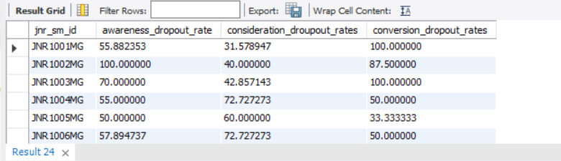

**INFERENCE- Business team can see the conversion or dropout rates every stage that at which stage most leads are backing off also business teams can see the lead stage condion every junior manager.**

**Team Performance-Conversion rate of leads under every junior manager and senior manager:**

select s.snr_sm_id,l.jnr_sm_id,

count(distinct l.lead_id) as leads,

count(distinct case when l.lead_stage='conversion' then l.lead_id end) as converted_leads,

round(count(distinct case when lead_stage='conversion' then l.lead_id end)*100.00/count(distinct l.lead_id),2) as conversion_percentage

from leads_interaction_details l

left join sales_manager_assigned_leads_details s on l.lead_id=s.lead_id

group by l.jnr_sm_id,s.snr_sm_id;

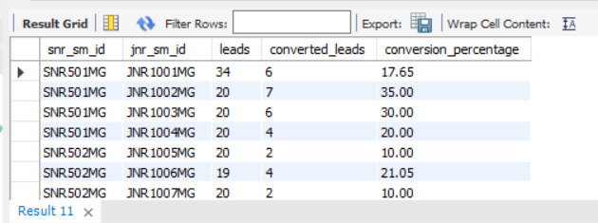

**INFERENCE- With this analysis business heads can know which team is most converting leads into final conversion. This is an indepth analyis in which we are getting individual performance report of junior and senior sales manger.**

**conversion rates by lead generation source and city:**

with base as(select a.*,b.lead_gen_source,b.current_city

from leads_interaction_details a

left join lead_basic_details b

on a.lead_id=b.lead_id)

select lead_gen_source,current_city,count(distinct lead_id) as leads,

count(distinct case when lead_stage='conversion' then lead_id end) as converted_leads,

round(count(distinct case when lead_stage='conversion' then lead_id end)*100/count(distinct lead_id),2) as coversion_rate

from base group by 1,2

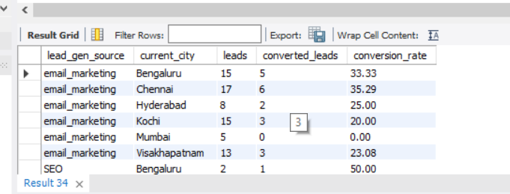

**INFERENCE-With this analysis we are getting conversion rates per lead gen source and city. This is a very deep analysis and can be used to know in which city which lead gen source is not giving good results.**